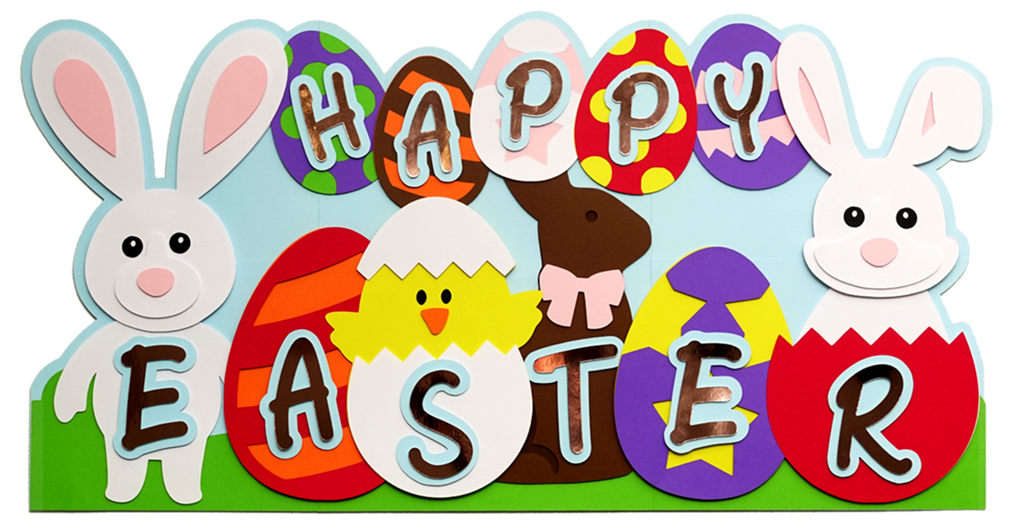

**Easter Buffet**

**10AM-2PM**

**Carvery Station: Double Smoked Ham, Turkey Breasts, Leg of Lamb,**

**Fresh Atlantic Salmon, Honey Baked Chicken, Stuffed Pork Loin, Swedish Meatballs and Fresh Assorted Fish.**

**Assorted Pastas, Garlic Mashed Potatoes, Honey Carrots, Beer Mac & Cheese, Stuffing, and Gravy.**

**Full Soup and Salad Bar.**

**Cold Seafood Bar: Peel & Eat Shrimp, Smoked Salmon, and Assorted Cheeses.**

**Full Breakfast Station**

**Homemade Dessert Bar**

**Adults: $27.95 Kids: 5-10 $14.95 Kids Under 5: Free**